23. Workbench, Salesforce Extensions - 26 March 2022

1] Workbench

2] Salesforce Extensions

1] Workbench

It is a web based tool which is used to perform Insert, Update, Upsert, Delete, Hard Delete, Export , Export All.

OR

Workbench is a web-based tool designed for [Salesforce Admin](http://www.apexhours.com/salesforce-admin-training-free/) and [Developers](https://www.apexhours.com/apex-hours-for-students-developer-program/) which allow them to interact with Salesforce organization to insert, update, delete, search and export data. Using the Salesforce Workbench tool, they can easily perform SOQL and SOSL, view their organization’s data, perform data loading and testing, deploy and troubleshoot of their applications, and modify session settings.

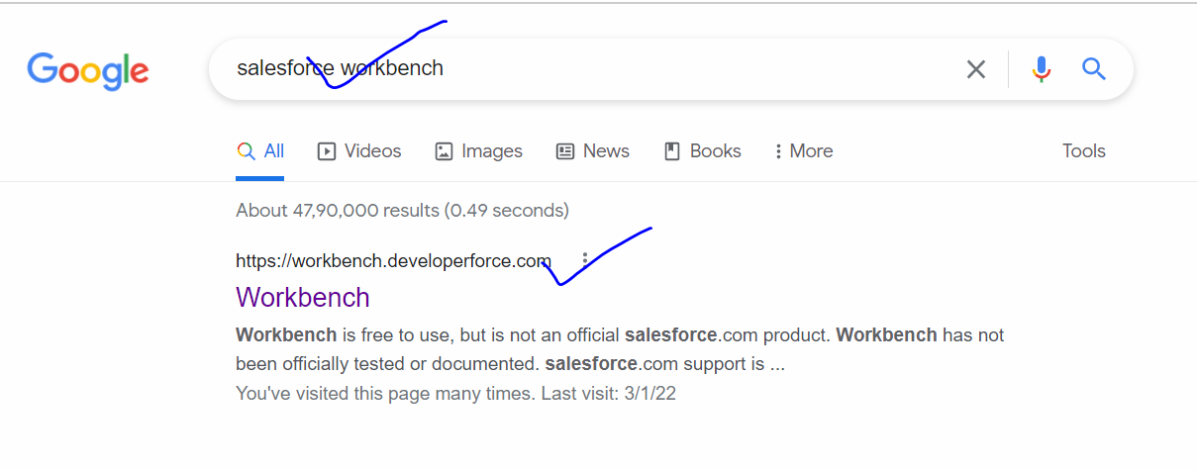

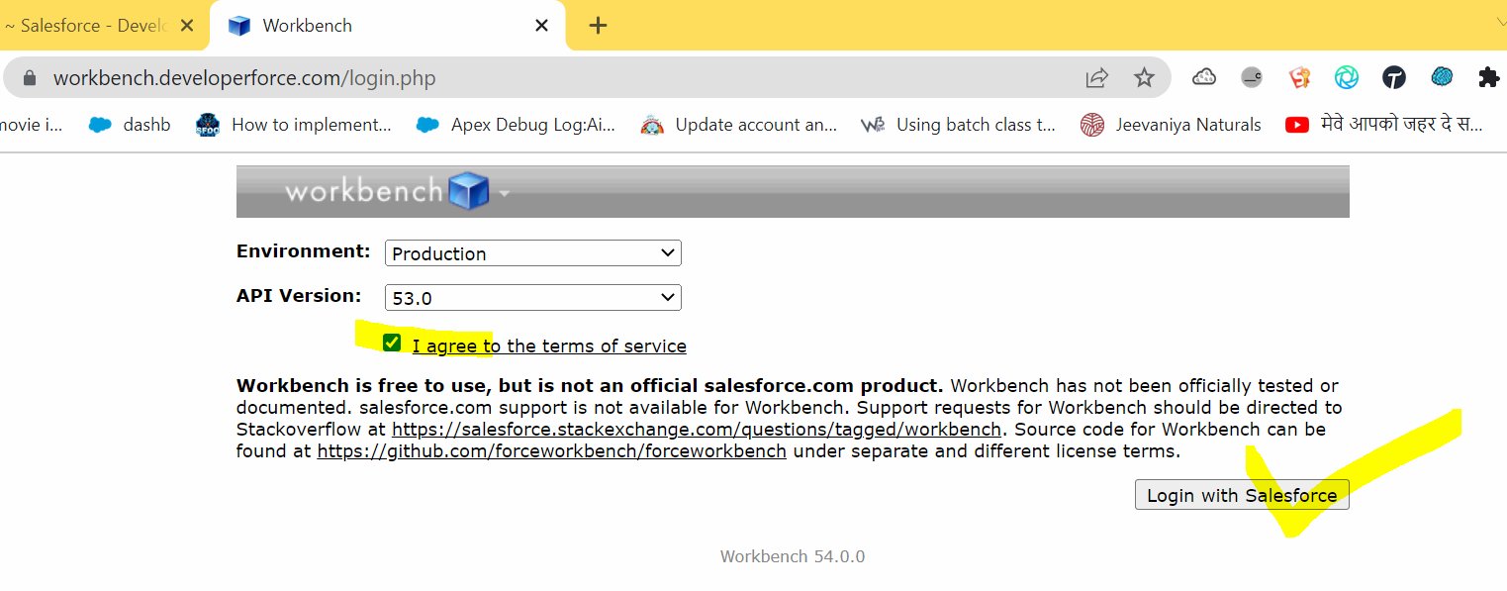

Operations

Insert

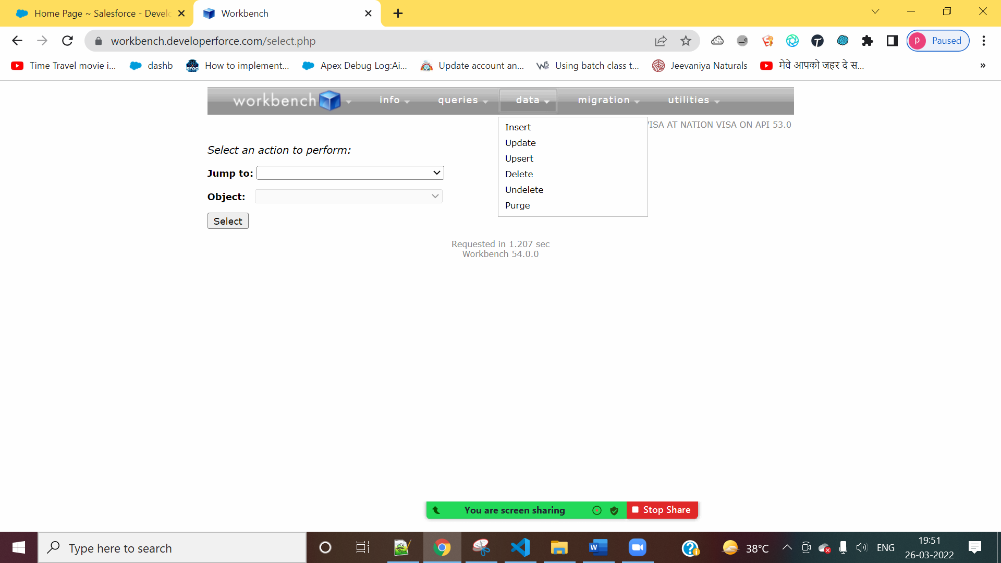

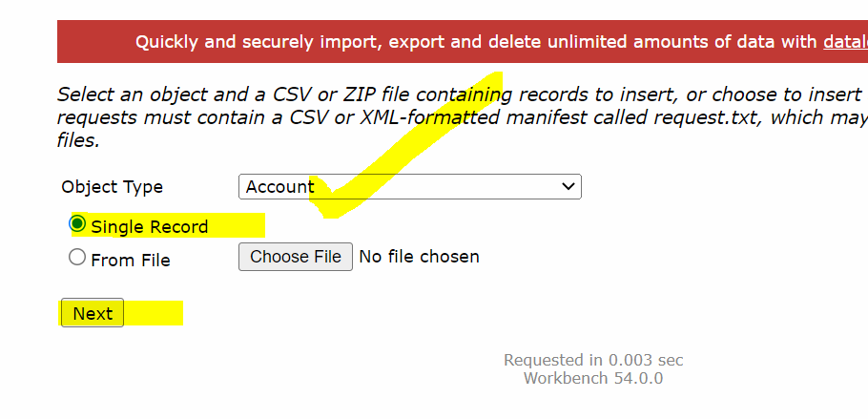

Update

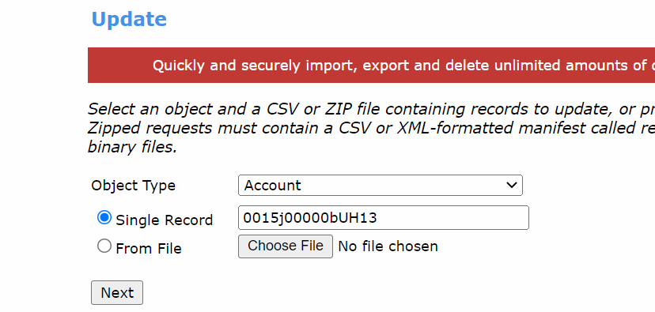

Upsert

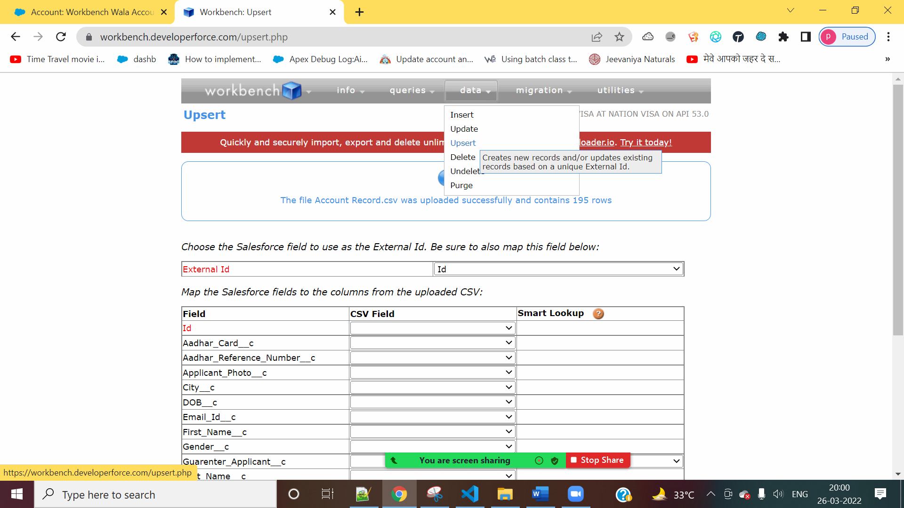

Delete

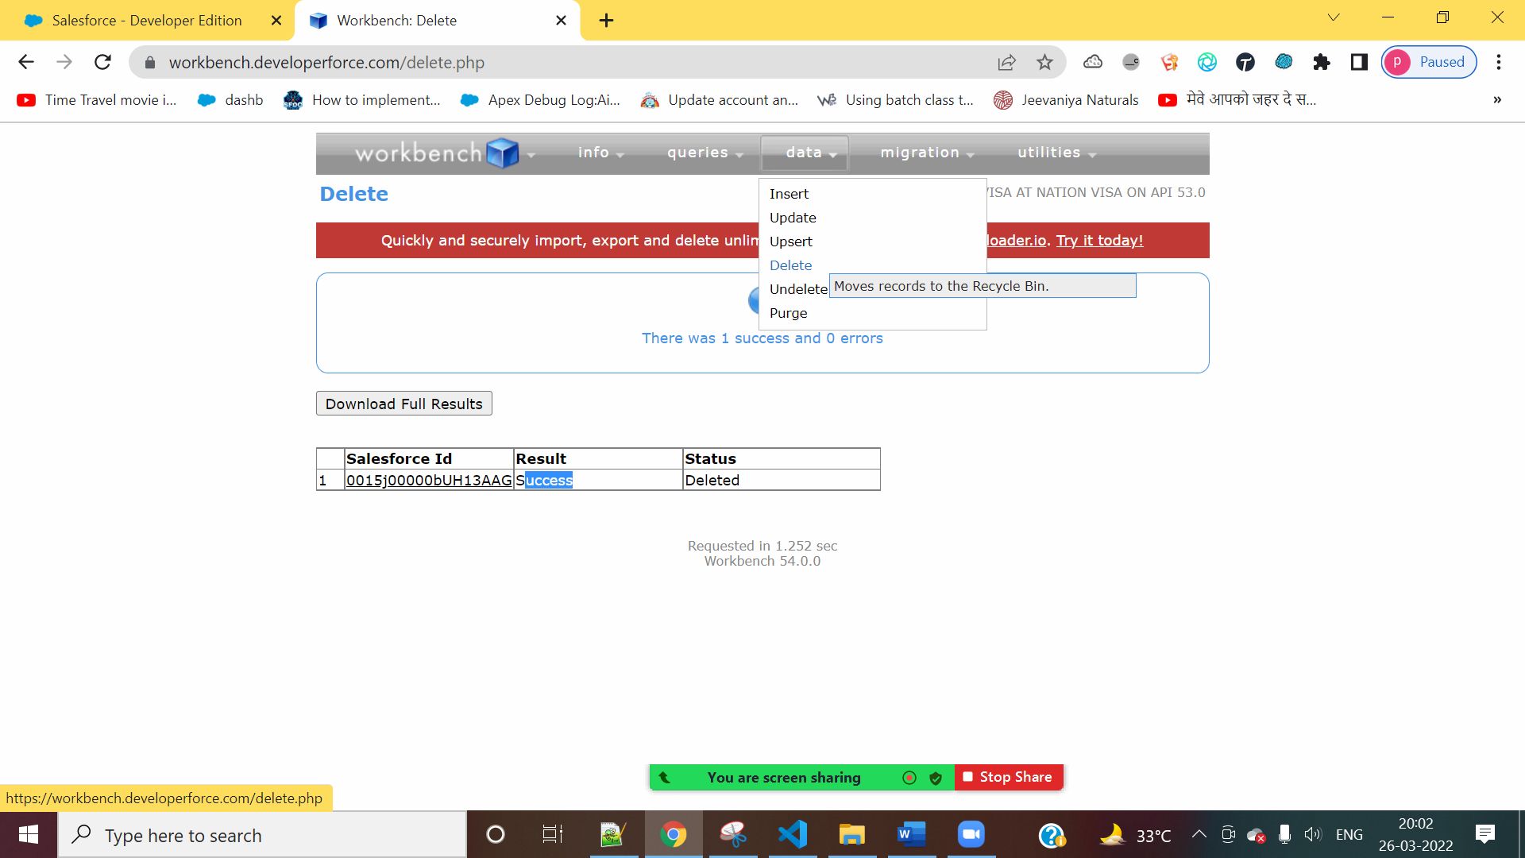

Hard Delete

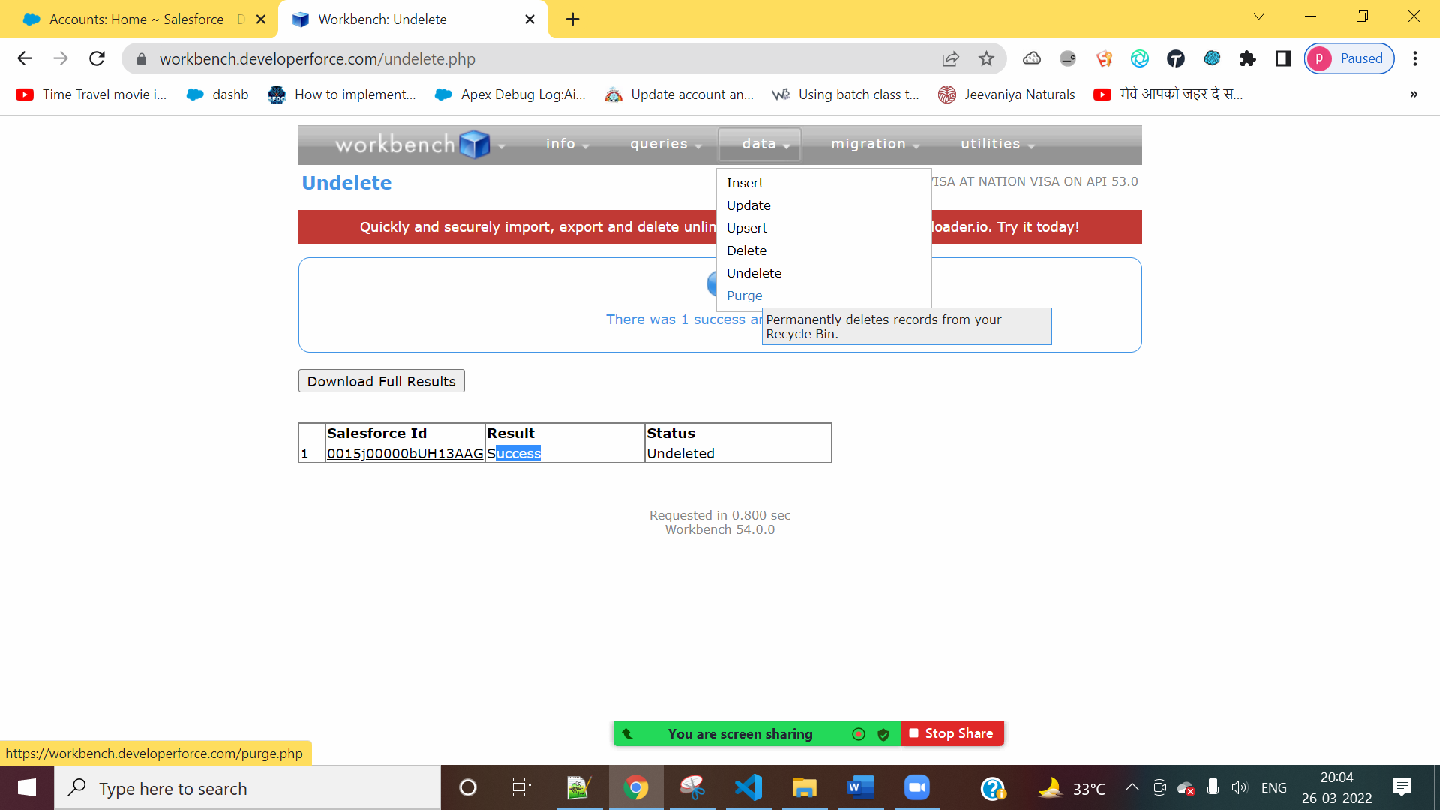

Export

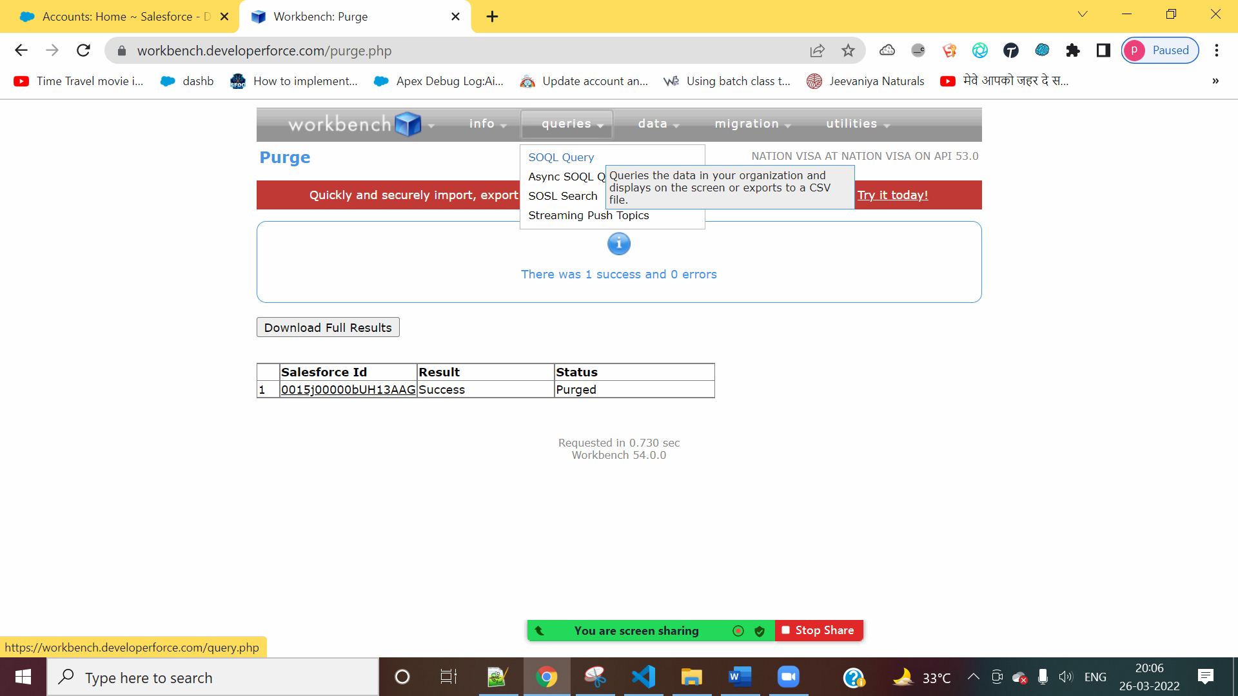

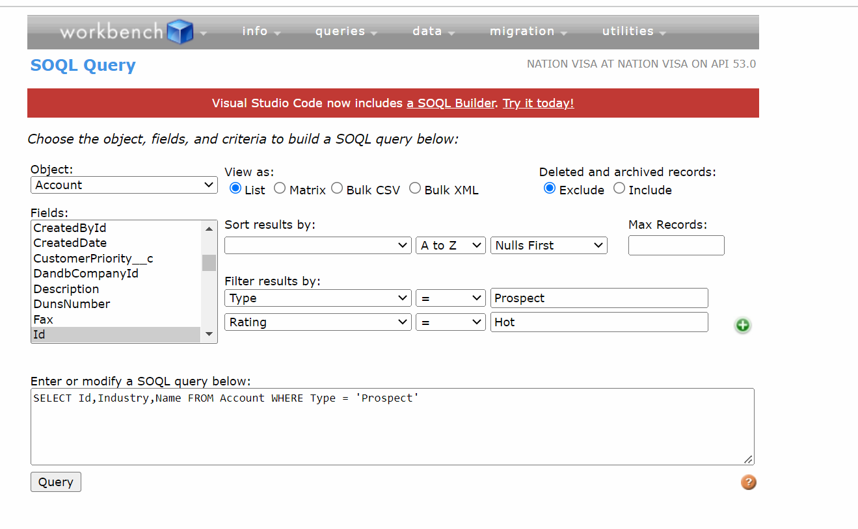

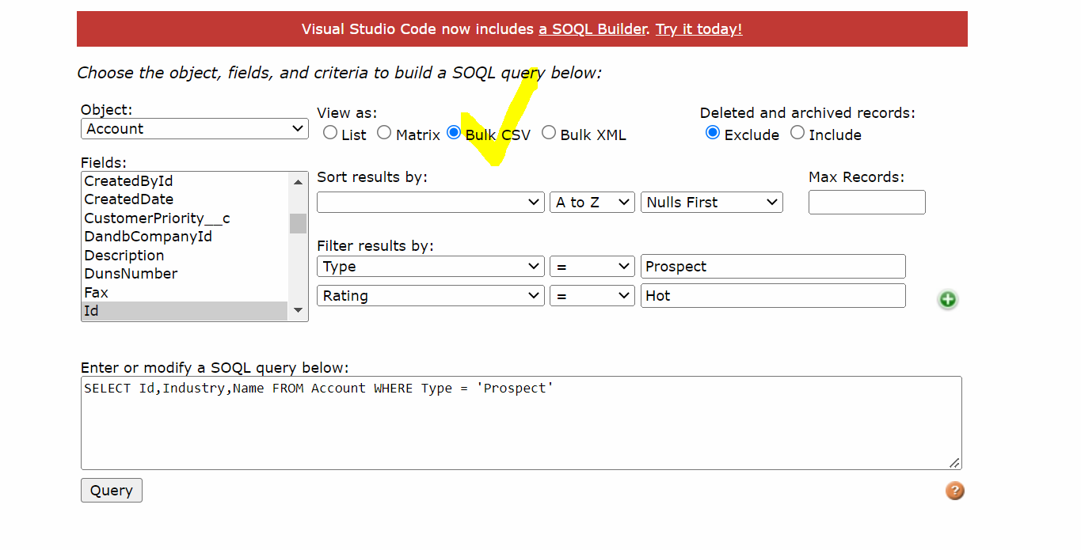

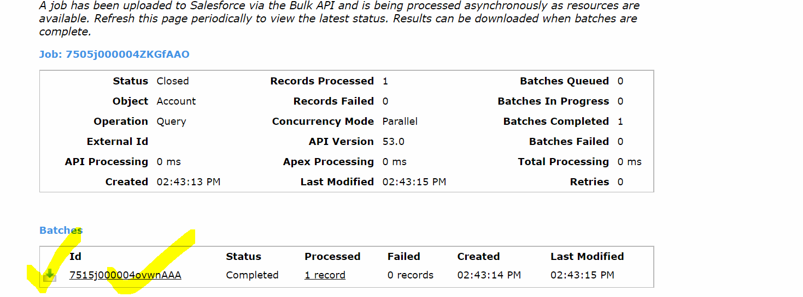

IN ORDER

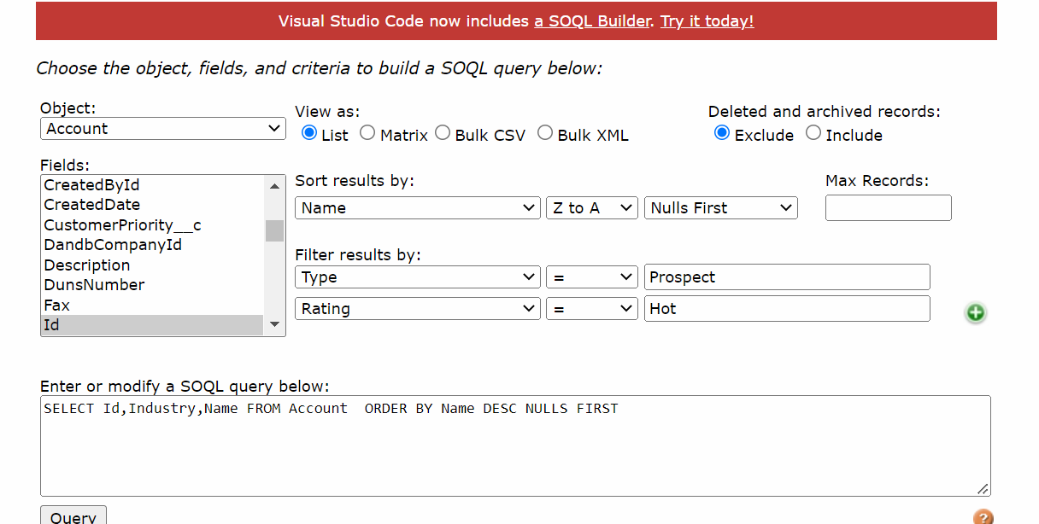

LIMIT 5:

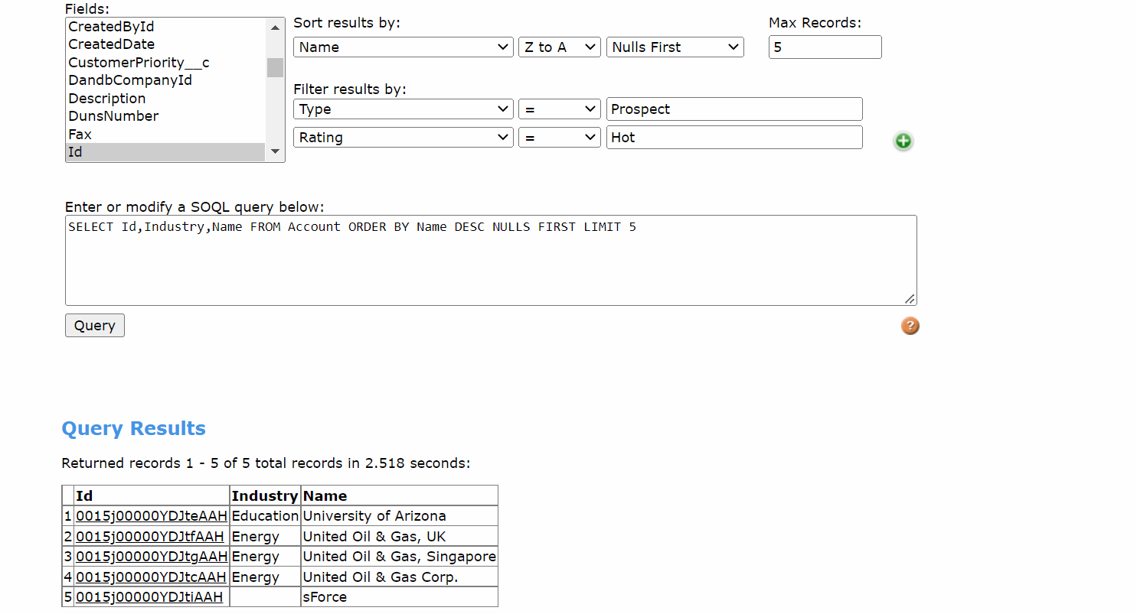

Export All

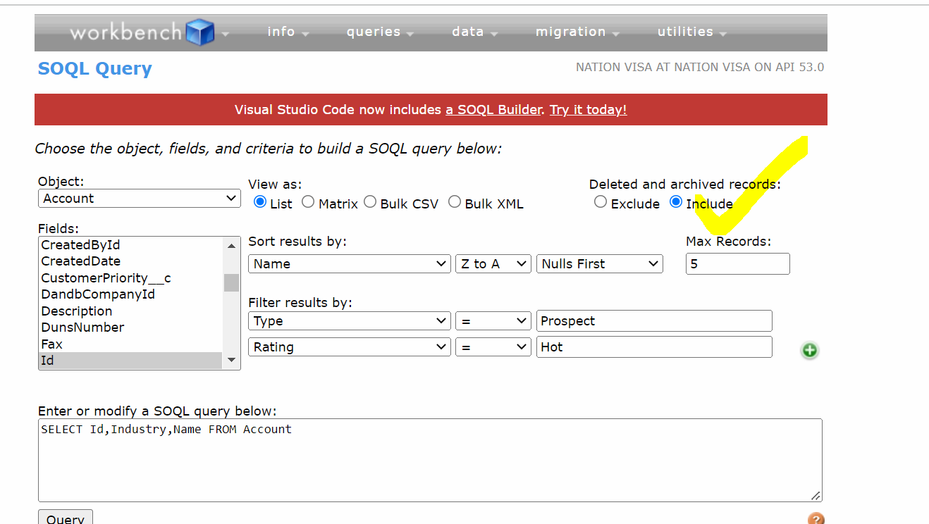

EXTRA FACILITIES

INFO:

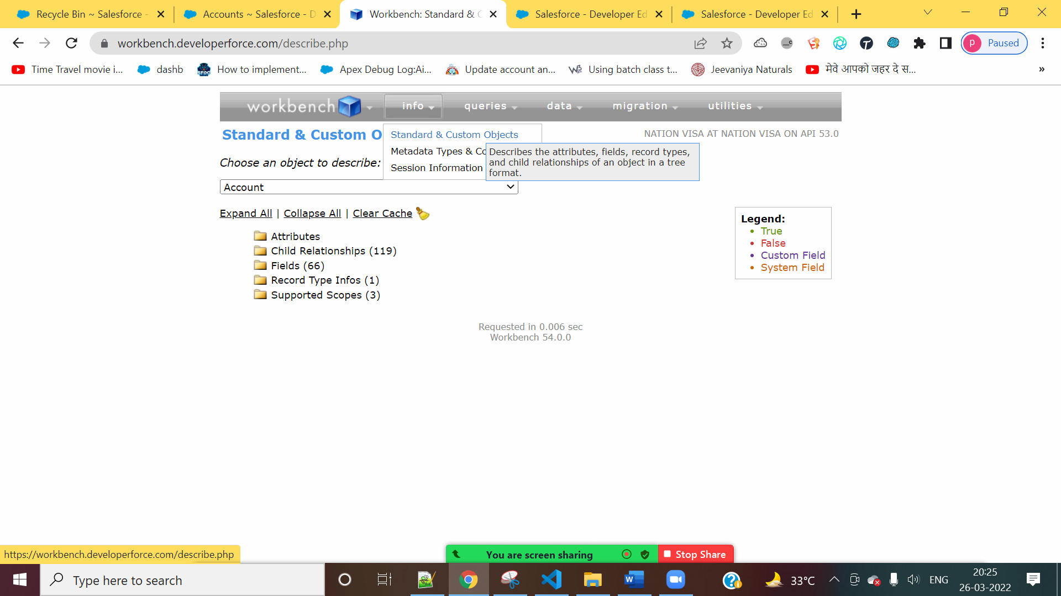

Activity History:

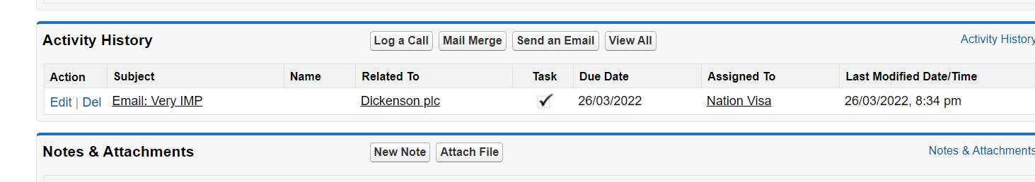

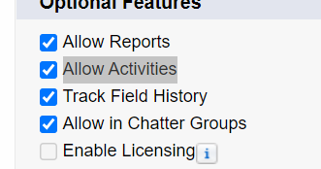

2] Salesforce Extensions

https://blog.cloudanalogy.com/top-10-salesforce-extensions-for-chrome/

A] Salesforce Advanced Code Searcher

B] Salesforce Field API Names

C] Salesforce Inspector

D] Salesforce Force Login

E] Salesforce ChangeSet Helper

F] [Salesforce Navigator](https://chrome.google.com/webstore/detail/salesforce-navigator/ecjmdlggbilopfkkhggmgebbmbiklcdo)

A] Salesforce Advanced Code Searcher

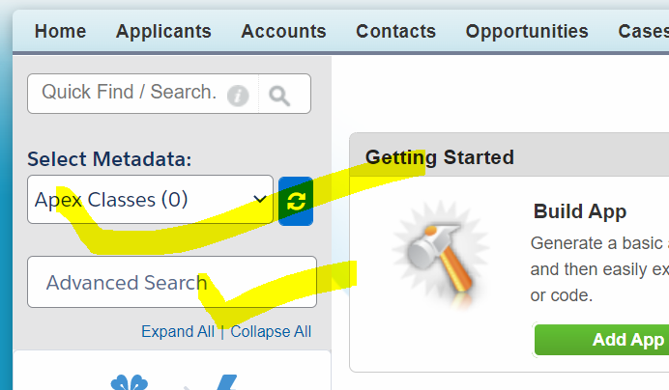

B] Salesforce Field API Names

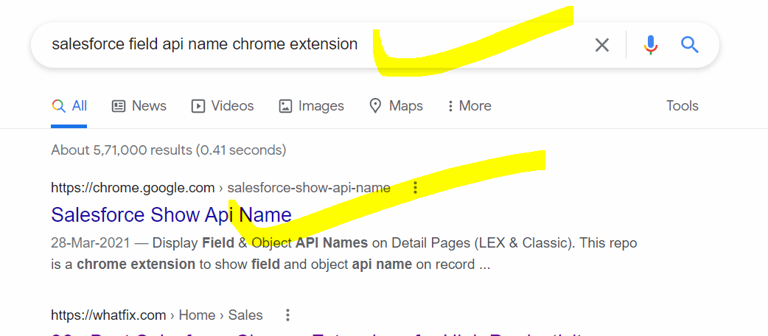

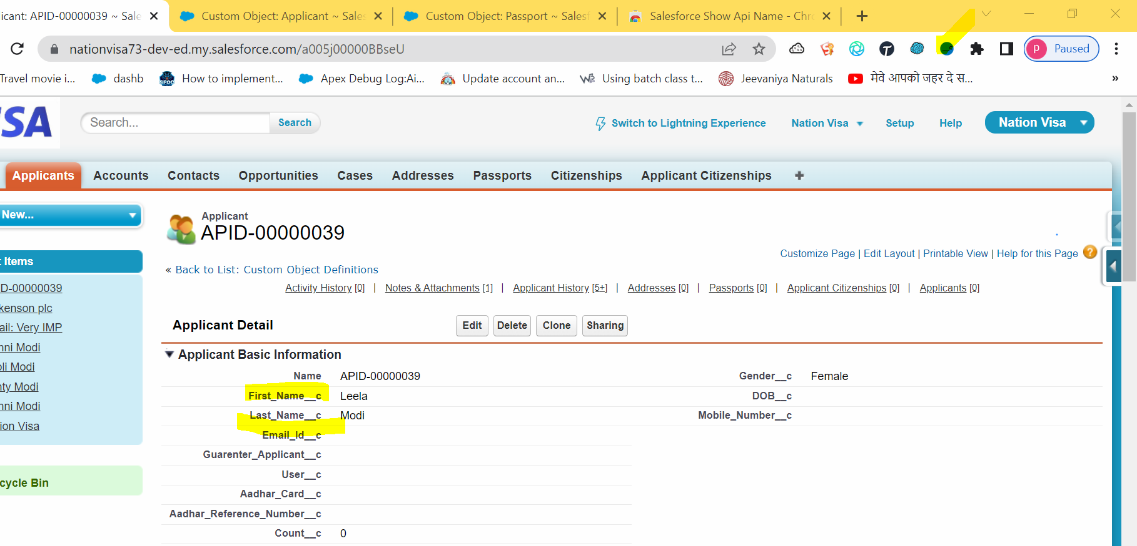

C] Salesforce Inspector

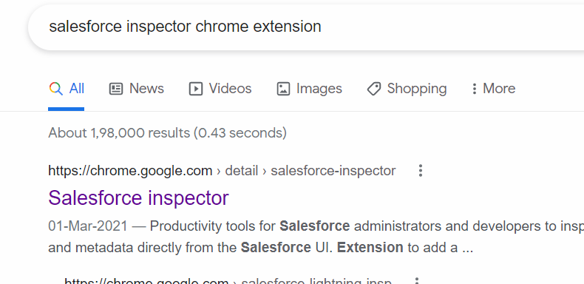

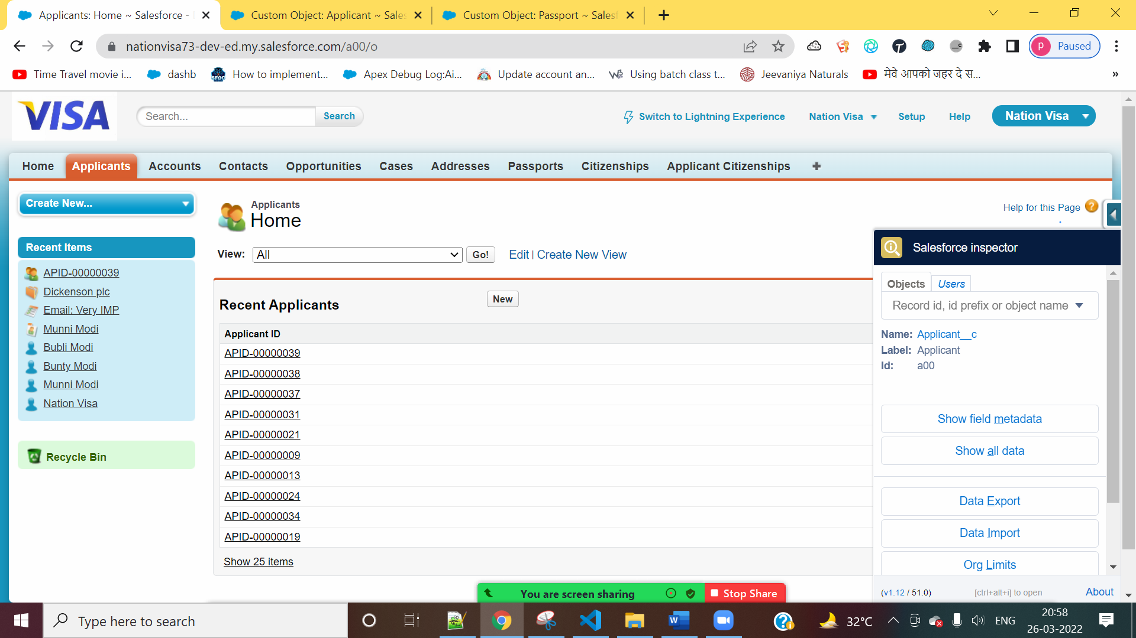

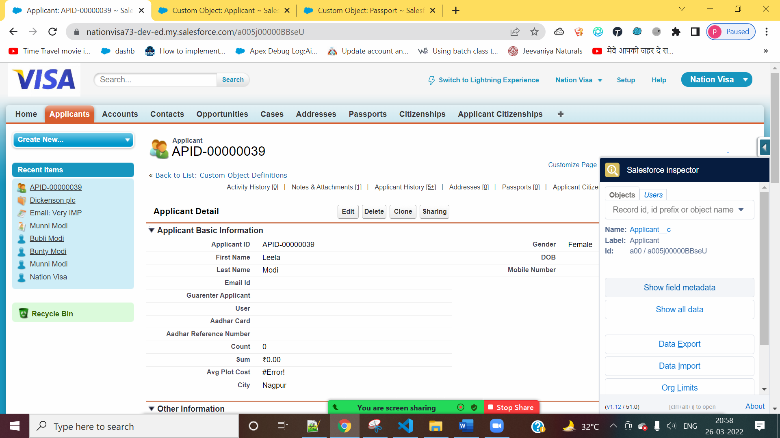

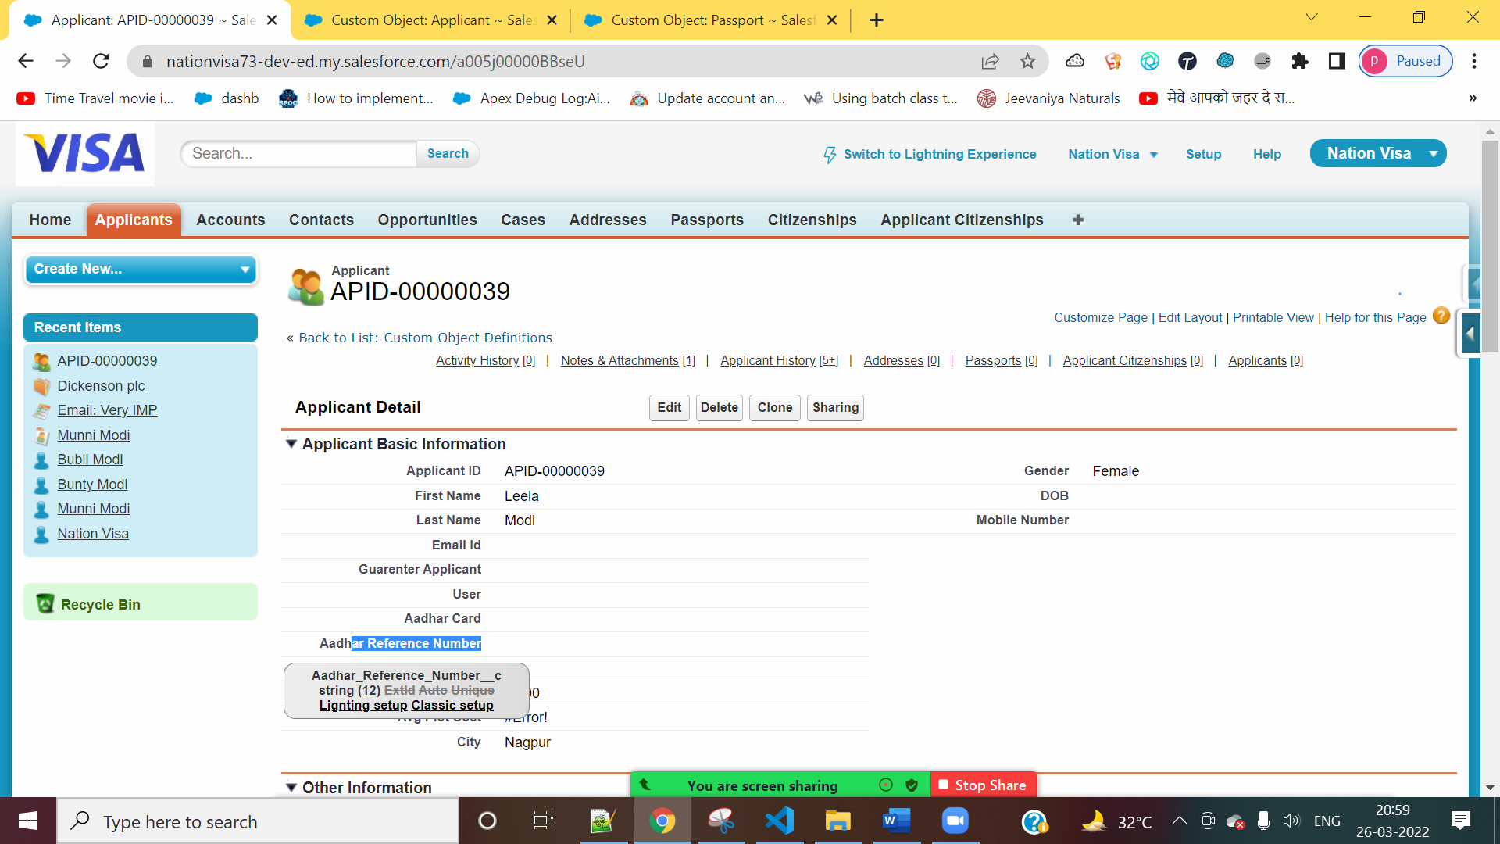

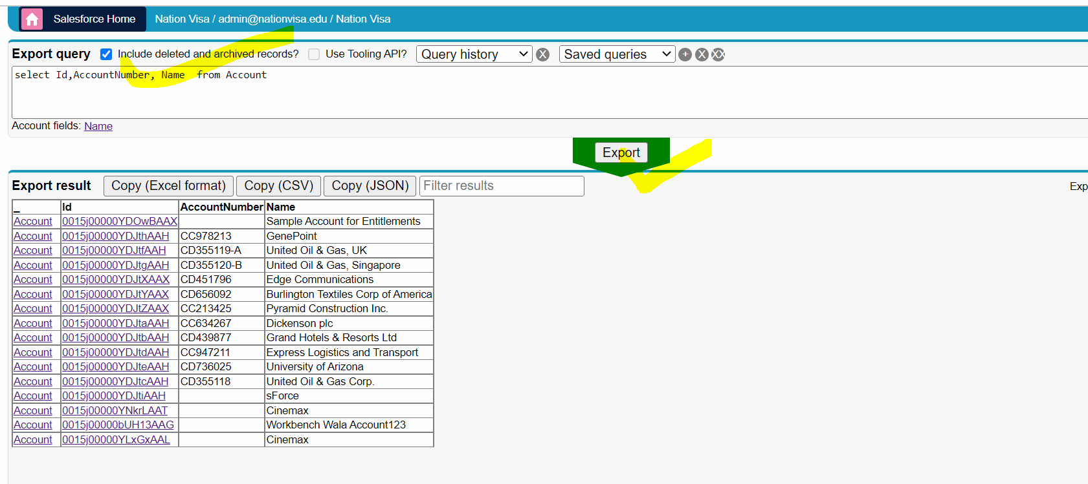

D] Salesforce Force Login

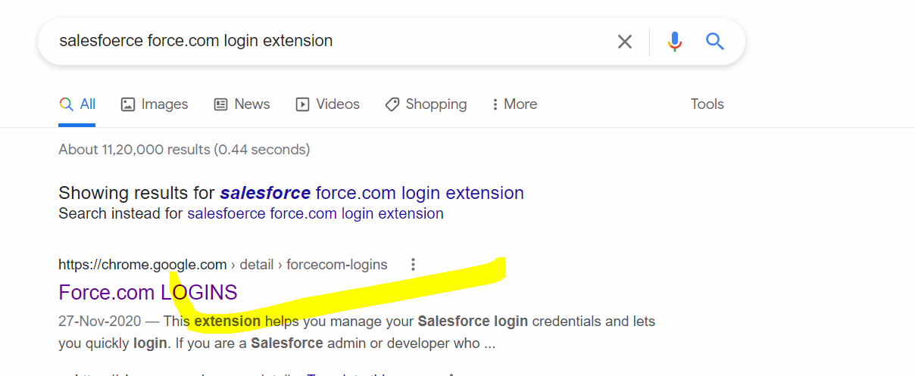

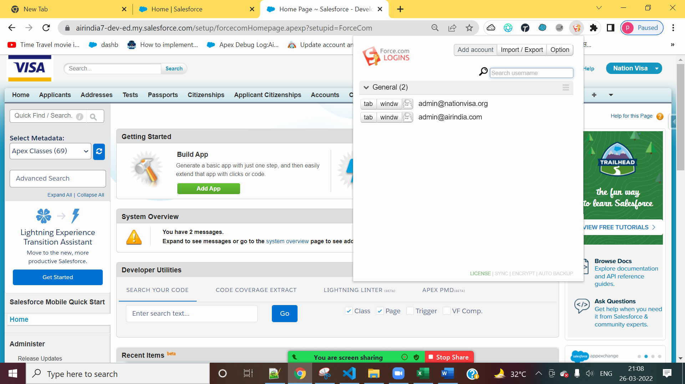

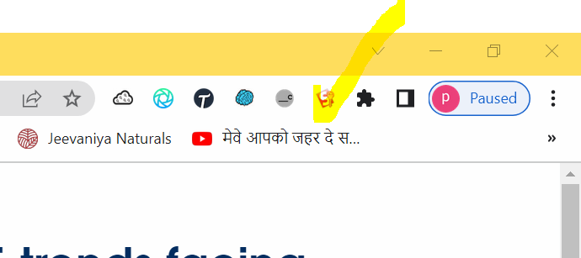

E] Salesforce ChangeSet Helper

F] [Salesforce Navigator](https://chrome.google.com/webstore/detail/salesforce-navigator/ecjmdlggbilopfkkhggmgebbmbiklcdo)

H] Salesforce Dev Tool

